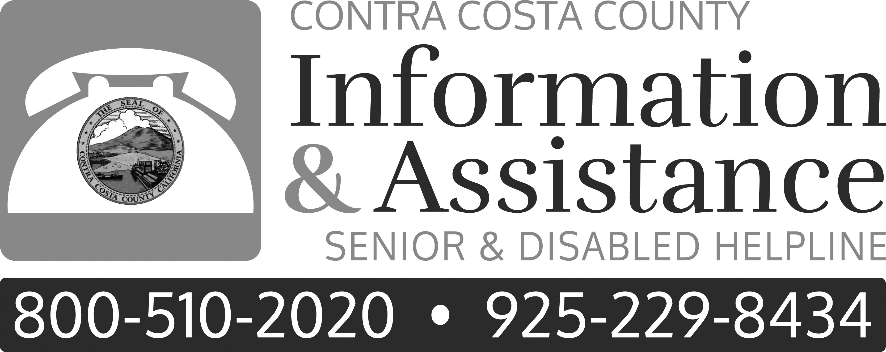
East County
Senior Centers & Community Centers
Ambrose Community Center | 3105 Willow Pass Road  Bay Point, CA 94513 |  | (925) 458-1601 | Monday- Friday  8:30 am- 5:00 pm
Antioch Senior Center | 415 West 2nd Street  Antioch, CA 94509 |  | (925) 778-1158 | Monday- Friday  8:00 am- 4:00 pm
Brentwood Senior Activity  Center | 193 Griffith Lane  Brentwood, CA 94513 |  | (925) 516-5380 | Mon-Thu 9 am-4:30 pm  Friday 9:00 am-3 pm
Pittsburg Senior Center | 300 Presidio Lane  Pittsburg, CA 94565 |  | (925) 252-4890 | Monday-Friday  9:00 am-4:00 pm
Well Connected-Covia | (telephone groups) |  | (877) 797-7299
Senior Clubs & Organizations
Congress of California Seniors |  | 1230 N Street, Suite 201  Sacramento, CA 95814 | (800) 543-3352  (916) 442-4474
East County Senior Coalition  Rivertown Resource Center |  | 301 West 10th Street  Antioch, CA 94509 | (925) 778-1158 | Every 2nd Wednesday  9:30 am- 12:00 pm
Commissions on Aging
Antioch Commission on Aging |  | 415 West 2nd Street  Antioch, CA 94509 | (925) 778-1158 | Every 2nd Wednesday  9:00 am
AA Advisory Council on Aging |  | 500 Ellinwood Way  Pleasant Hill, CA 94523 | (925) 602-4175 | 1st Wed except  July and August
This fact sheet is provided by the Contra Costa County Information and Assistance Program.
Please contact us at:

(925) 229-8434 or (800) 510-2020
TDD (impaired hearing): (925) 602-4198
TTY (impaired hearing): (925) 602-4198
This information is current as of March 2019

