Contra Costa County
Advisory Council on Aging
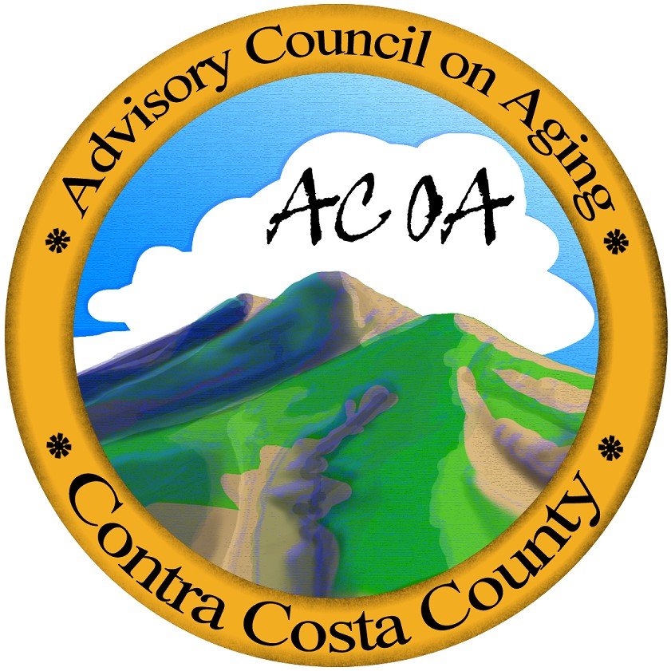
PLEASE CONTACT JAIME RAY AT (925) 602-4172 IF YOU ARE UNABLE TO MAKE THIS MEETING WITHIN 24 HOURS OR IF YOU ARE LATE

Aging & Adult Services
400 Ellinwood Way
Pleasant Hill, CA 94523
(925) 602-4172 – Office
(925) 602-4178 - Fax
Fragrance Reminder:
For the health and comfort of others, please do not wear strong smelling personal products (perfumes, hair products, after shave, etc.)

Notice of Meeting: Advisory Council on Aging
Wednesday, September 17, 2014 • 9:30 – 11:35 a.m.
500 Ellinwood, Board Rooms A/B, Pleasant Hill
AGENDA
Public comment on specific Council discussion items below should be held until after all Council Members have had an opportunity to provide their input on the item (and just before a formal vote is taken, assuming it is an action item). Public comment will be limited to three minutes per person.

 | 9:30 | Call to Order & Introduction of Guests |  |  | Dr. Robert Leasure
1 | 9:32 | Pledge of Allegiance |  |  | Dr. Robert Leasure
2 | 9:35 | Roll Call |  |  | Richard Nahm
3 | 9:40 | Announcements and Correspondence |  |  | Dr. Robert Leasure
4 | 9:45 | Public Comment on Agenda Items |  |  | Dr. Robert Leasure
5 | 9:47 | Approval of Today’s Agenda |  |  | Dr. Robert Leasure
6 | 9:50 | Approval of August 20, 2014 Minutes |  |  | Dr. Robert Leasure
7 | 9:55 | Aging & Adult Services Director’s Report |  |  | John Cottrell
8 | 10:05 | Program Manager’s Report |  |  | Lori Larks
9 | 10:10 | President’s Report  - November ACOA Recess / Annual Reports: November 15 Deadline |  |  | Dr. Robert Leasure
10 | 10:20 | Debbie Toth, CEO / RSNC - Regional Coalition Updates |  |  | Debbie Toth
11 | 10:25 | Consent Items(s): For ACOA Approval |  |  | Dr. Robert Leasure
 |  | - Vacate MAL #17 Seat

12 | 10:30 | BREAK
13 | 10:40 | Presentation: The Conversation Project - Donald Waters, Alameda-Contra Costa Medical Association/East Bay ACP Project and Linda Best (Chair) East Bay Leadership Council.
14 | 11:15 | Committee / Work Group Reports (2 minutes each):  **PLEASE LIMIT YOUR REPORT TO TWO MINUTES** |  |  |  | Dr. Robert Leasure
 |  | - Legislative Advocacy | - Nutrition | - Health | - Rx Drug Coalition
 |  | - Transportation | - Planning | - Ed. & Outreach | - Meals on Wheels
 |  | - Membership/Nominating | - Senior Coalitions | - Housing
15 | 11:25 | Public Comment |  |  |  | Dr. Robert Leasure
 | 11:30 | Adjournment |  |  |  | Dr. Robert Leasure
Any disclosable public records related to an open session item on a regular meeting agenda and distributed by Contra Costa County to a majority of members of the Advisory Council on Aging less than 96 hours prior to that meeting are available for public inspection at 400 Ellinwood Way, Pleasant Hill.
The Contra Costa County Advisory Council on Aging and its committees will provide reasonable accommodations for persons with disabilities planning to attend the above noticed meeting if they call Jaime Ray at 925-602-4172 at least 48 hours in advance of the meeting.

Contra Costa County Advisory Council on Aging is appointed by the Board of Supervisors to advise the Area Agency on Aging on all matters related to the development and administration of the annual Area Agency Plan and operations conducted thereunder, in accordance with mandates from the Older Americans Act. Any comments or recommendations made by the council or its individual members do not represent the official position of the County or any of its officers.

